Clinical Representative for Standard Process and Medi Herb
Cell/text: 650-454-4895
Order: 1 800 558-8740
sporders@standardprocess.com
kim@kimsperryconsulting.com
www.kimsperryconsulting.com

STANDARD PROCESS CALCIFOOD WAFERS– for hair, teeth, bones and nails! Source of keratin, glucosamine/chondroitin sulphate, raw bone protein, bone marrow, collagen and gelatin- considered to be a bone broth in a tablet/powder form.
Keratin is a protective protein that makes up your hair, skin, and nails. Ker atin can also be found in your internal organs and glands.
Glucosamine helps to keep the cartilage around bones intact and prevent them from diminishing over time and with age. Chondroitin sulfate (CS) is a major component of many connective tissues, including cartilage, bone, skin, ligaments and tendons. Osteoarthritis (OA) is characterized by progressive structural and metabolic changes in joint tissues, mainly cartilage degradation, subchondral bone sclerosis and inflammation of synovial membrane.
CS is a sulfated glycosaminoglycan-responsible for many of the important bio-mechanical properties of cartilage, such as resistance and elasticity.
CS has been reported to have anti-inflammatory effects. It was shown to inhibit in vitro the synthesis of various inflammatory intermediates, such as nitric oxide (NO) synthase, cyclooxygenase (COX)-2, microsomal prostaglandin synthase (mPGES)-1 and prostaglandin (PG) E2 [Campo et al. 2009a; Legendre et al. 2008; Chan et al. 2005b; Bassleer et al. 1998].
Raw bone protein is invaluable support for proper functioning of joints. This is a necessary ingredient for building new tissues and muscle structures. High-quality protein is a constituent of synovial fluid. Made from spines & ribs of raw veal bone-feeding this to my cat as a paste to keep her teeth strong. She goes nuts for Calcifood wafers. Wheat germ is used to absorb the bone marrow, collagen and gelatin.
Collagen is the main connective tissue protein that provides the right cushioning and elasticity to the joints. Collagen forms the structure of tendons, ligaments, joints and intervertebral discs. The strength and resistance of cartilage depends from it. Proper collagen suppression prevents the occurrence of autoimmune diseases associated with the destruction of articular cartilage. This increases joint mobility and flexibility. Collagen is an indispensable bone building ingredient. Vitamin C provided better absorption of collagen.

Bone protein needs to be raw. Calcifood is not to be confused with bone meal products which are steamed/dead. Phosphorus important for energy. No energy + exhaustion + feeling worn out = potential need for phosphorus. Rice bran source of riboflavin- in a riboflavin deficiency, calcium has a tendency to accumulate in soft tissues where it does not belong; the most profound effect of this is cataracts.

This bone–building food is a source of rare amino acids, consisting of 50 percent protein and 50 percent minerals. The protein derived from the raw bone meal in Calcifood Powder is high in amino acids that are commonly lost in cooking.
Supports protein metabolism and immune system response function as well as skeletal and muscular and cellular health. Also supports healthy protein metabolism and contains the essential amino acid lysine, needed for proper collagen formation.
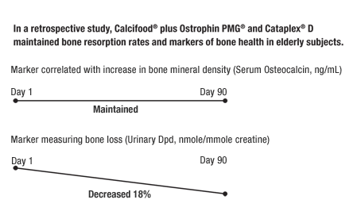
In a retrospective study, Calcifood, Ostrophin PMG, and Cataplex D maintained bone-resorption rates in elderly subjects, as measured by two markers of bone health.†
Calcifood Success Story provided by W. Friedman in Marin County:

“My cat LOVES Calcifood wafers as well! She had dental problems when I got her at about 1 year old, and lost a tooth. (she was a rescue cat that had a littler at a very young age, and was malnourished when I got her). I've been giving her SP Bio-dent or Calcifood ever since (along with occasionally cleaning gums with a q-tip and various dental preparations). She never lost another tooth. She's about 14 now.
I always "share" with her if I'm taking them. Now, every time she hears a SP process bottle shake, she perks up”.

