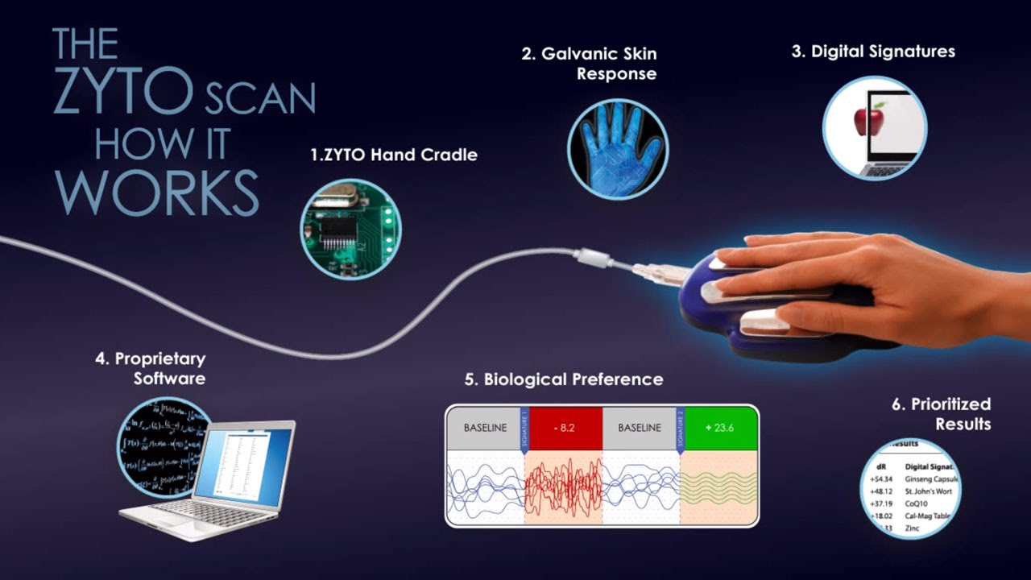
Bio energetic medicine hand scanning, known as ZYTO allows you to:

Measure the energetic stress of your organs and systems

Pinpoint specific remedies to bring your body back into balance

It creates an electronic “conversation” between the client skin (the largest organ) and the software program.

The program begins to pinpoint the best approach to bring the body back into balance with foods, supplements, herbs and/or natural remedies that are most compatible with it.

Vaughn R Cook founded ZYTO and has served as Chairman of the Board and Chief Executive Officer since its incorporation in December of 2004. He has been employed full time by ZYTO since its inception. Dr. Cook is an honors graduate of Utah State University, has an acupuncture degree from the Oriental Medical Institute of Hawaii, and an OMD (Oriental Medical Doctor) degree from the North American Academy of Advanced Asian Medicine.

https://www.zyto.com/learning/biocommunicationhistory

