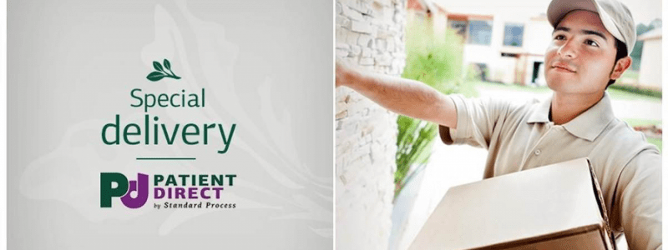

Getting Your Supplements Just Got Easier
Now you can order Standard Process and MediHerb supplements right to your door!
If you’re a fan of Standard Process and want to order supplements from the convenience of your own home, you’ll be excited to learn about a new program being offered called Patient Direct. Even better, you’ll have access to the entire Standard Process, Mediherb, and Veterinary line of products!

How It Works
- Visit the Patient Direct Sign-up page ( https://www.standardprocess.com/Patient-Direct/patient-registration )
- Review the Terms & Conditions
- Enter my Patient Direct Code: Contact Us to get your code
- Standard Process will contact me to verify your account.
- I’ll let you know once you’re approved and you can begin ordering.

About the Patient Direct Program
Our Patient Direct™ by Standard Process® ordering program allows you to order your supplements directly from us online from the comfort of your own home. Your supplements will then be delivered to your address.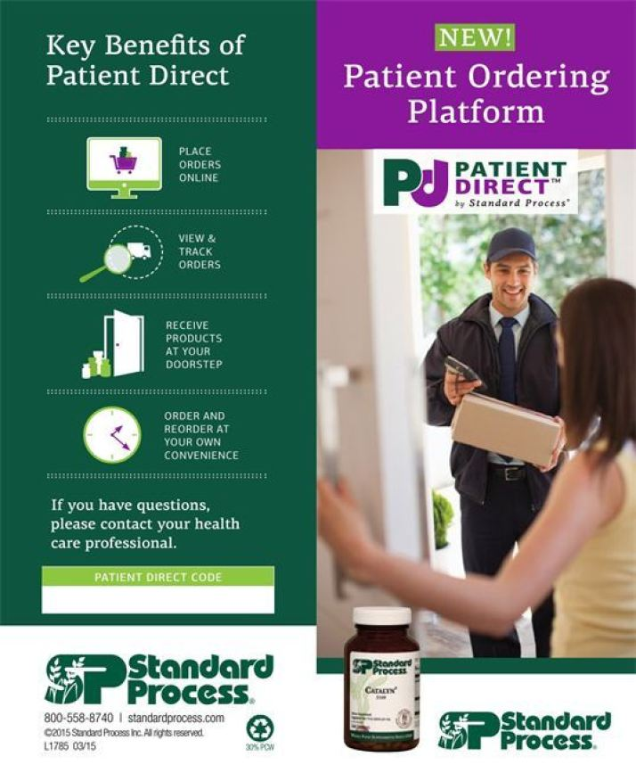
This new tool offers you several benefits:
- You’ll save time by ordering and reordering supplements online, at your own convenience.
- You’ll be able to maintain your supplement health regimen even if you’re traveling.
- You’ll save time and money by not having to drive to pick up your supplements.
- Your supplements will be delivered directly to you.
If you are a current patient and interested in using this new convenience, please use our Patient Direct code: Contact Us to get your code
This code is required to begin the application process for your online ordering account through Patient Direct by Standard Process, and may be used by current patients only. Sign up for an account at standardprocess.com today!

Why To order Your Supplements Here
Simply Put: Quality Controlled Pure Nutrition, Straight to your doorstep.
Standard Process ensures the quality and safety of their products by selling only through licensed healthcare professionals.
Products sold through Amazon or Ebay have are often expired, rancid, and have been stored in unsafe conditions. Make sure to get your Standard Process & Mediherb products only through a licensed professional with an active account.

This new tool offers you several benefits:
- You’ll save time by ordering and reordering supplements online, at your own convenience.
- You’ll be able to maintain your supplement health regimen even if you’re traveling.
- You’ll save time and money by not having to drive to pick up your supplements.
- Your supplements will be delivered directly to you.
If you are a current patient and interested in using this new convenience, please use our Patient Direct code: Contact Us to get your code
This code is required to begin the application process for your online ordering account through Patient Direct by Standard Process, and may be used by current patients only. Sign up for an account at standardprocess.com today!

Why To order Your Supplements Here
Simply Put: Quality Controlled Pure Nutrition, Straight to your doorstep.
Standard Process ensures the quality and safety of their products by selling only through Licensed healthcare professionals.
Products sold through Amazon or Ebay have are often expired, rancid, and have been stored in unsafe conditions. Make sure to get your Standard Process & Mediherb products only through a Licensed professional with an active account.

Getting Your Supplements Just Got Easier
by Tray on June 30, 2020 in Uncategorized
Now you can order Standard Process and MediHerb supplements right to your door!
If you’re a fan of Standard Process and want to order supplements from the convenience of your own home, you’ll be excited to learn about a new program being offered called Patient Direct. Even better, you’ll have access to the entire Standard Process, Mediherb, and Veterinary line of products!

How It Works
- Visit the Patient Direct Sign-up page
- Review the Terms & Conditions
- Enter my Patient Direct Code: Contact Us to get your code
- Standard Process will contact me to verify your account.
- I’ll let you know once you’re approved and you can begin ordering.

About the Patient Direct Program
Our Patient Direct™ by Standard Process® ordering program allows you to order your supplements directly from us online from the comfort of your own home. Your supplements will then be delivered to your address.
This new tool offers you several benefits:
- You’ll save time by ordering and reordering supplements online, at your own convenience.
- You’ll be able to maintain your supplement health regimen even if you’re traveling.
- You’ll save time and money by not having to drive to pick up your supplements.
- Your supplements will be delivered directly to you.
If you are a current patient and interested in using this new convenience, please use our Patient Direct code: Contact Us to get your code
This code is required to begin the application process for your online ordering account through Patient Direct by Standard Process, and may be used by current patients only. Sign up for an account at standardprocess.com today!

Why To order Your Supplements Here
Simply Put: Quality Controlled Pure Nutrition, Straight to your doorstep.
Standard Process ensures the quality and safety of their products by selling only through Licensed healthcare professionals.
Products sold through Amazon or Ebay have are often expired, rancid, and have been stored in unsafe conditions. Make sure to get your Standard Process & Mediherb products only through a Licensed professional with an active account.

Getting Your Supplements Just Got Easier
by Tray on June 30, 2020 in Uncategorized
Now you can order Standard Process and MediHerb supplements right to your door!
If you’re a fan of Standard Process and want to order supplements from the convenience of your own home, you’ll be excited to learn about a new program being offered called Patient Direct. Even better, you’ll have access to the entire Standard Process, Mediherb, and Veterinary line of products!

How It Works
- Visit the Patient Direct Sign-up page
- Review the Terms & Conditions
- Enter my Patient Direct Code: Contact Us to get your code
- Standard Process will contact me to verify your account.
- I’ll let you know once you’re approved and you can begin ordering.

About the Patient Direct Program
Our Patient Direct™ by Standard Process® ordering program allows you to order your supplements directly from us online from the comfort of your own home. Your supplements will then be delivered to your address.
This new tool offers you several benefits:
- You’ll save time by ordering and reordering supplements online, at your own convenience.
- You’ll be able to maintain your supplement health regimen even if you’re traveling.
- You’ll save time and money by not having to drive to pick up your supplements.
- Your supplements will be delivered directly to you.
If you are a current patient and interested in using this new convenience, please use our Patient Direct code: Contact Us to get your code
This code is required to begin the application process for your online ordering account through Patient Direct by Standard Process, and may be used by current patients only. Sign up for an account at standardprocess.com today!

Why To order Your Supplements Here
Simply Put: Quality Controlled Pure Nutrition, Straight to your doorstep.
Standard Process ensures the quality and safety of their products by selling only through Licensed healthcare professionals.
Products sold through Amazon or Ebay have are often expired, rancid, and have been stored in unsafe conditions. Make sure to get your Standard Process & Mediherb products only through a Licensed professional with an active account.

